**A**

**MINI PROJECT REPORT ON**

**“REAL-TIME CHAT APPLICATIONS”**

Project carried out

*By*

**Asit Kumar 2200350100018**

**Dheeraj Kumar 2200350100023**

**Akash Mahato 2200350100008**

**Saif Ullah 2200350100056**

**Babu Banarsi Das Institute of Technology (BBDIT)**

***Near, Duhai, Ghaziabad, Uttar Pradesh 201206***



**COURSE**: - B. TECH CSE 3RD YEAR

SESSION (2024-25)

**Under the supervision of**

**Date of Submission**

**Declaration**

**I hereby declare that the project titled "** **REAL-TIME CHAT APPLICATIONS " is a result of my own work and research. This project has been developed as part of my mini project for B.Tech in Computer Science Engineering (CSE) 3rd year at Babu Banarsi Das Institute of Technology (BBDIT).**

**I affirm that the work presented in this report is original and has not been submitted for any other academic purpose. All sources of information and references used in the preparation of this project have been duly acknowledged.**

**I would like to express my gratitude to my project supervisor, Ass. Prof. ANVISHA SHARMA, for their guidance and support throughout the development of this project. I also extend my thanks to my peers and family for their encouragement and assistance.**

**Course: B.Tech (CSE) 3rd year**

**Date:**

**Asit Kumar 2200350100018**

**Dheeraj Kumar 2200350100023**

**Akash Mahato 2200350100008**

**Saif Ullah 2200350100056**

**Prof. Name ANVISHA SHARMA**

**Department of Computer science Engg. Department of CSE**

**Acknowledgment**

**I would like to express my heartfelt gratitude to everyone who contributed to the successful completion of my project, "Real-Time Chat Applications."**

**First, I thank my project supervisor, Ass. Prof. ANVISHA SHARMA, for their invaluable guidance and support throughout the development of this project. Their insights were instrumental in shaping my work.**

**I also appreciate my classmates and friends for their collaboration and assistance. Their ideas and suggestions greatly enhanced the quality of the application.**

**Additionally, I am grateful to my family for their unwavering support and motivation, which kept me focused throughout this journey.**

**Finally, I acknowledge the online resources and documentation that provided essential information on the technologies used in this project, including HTML, CSS, JavaScript, Node.js, Socket.IO, and MongoDB.**

**Thank you all for your support and encouragement.**

Project carried out by

**Asit Kumar 2200350100018**

**Dheeraj Kumar 2200350100023**

**Akash Mahato 2200350100008**

**Saif Ullah 2200350100056**

**Date**

**Abstract**

**REAL-TIME CHAT APPLICATIONS is a real-time chat application designed to facilitate instant communication over the internet. Utilizing modern web technologies such as HTML, CSS, and JavaScript for the front-end, and Node.js with Socket.IO for real-time communication, REAL-TIME CHAT APPLICATIONS provides a seamless user experience. The application features user registration, instant messaging, and chat history storage using MongoDB. This project aims to enhance online communication by integrating these technologies into a user-friendly platform.**

**Technologies Used**

**The following technologies were utilized in the development of the ChatUp! application:**

* **HTML: For structuring the web pages and creating the user interface.**
* **CSS: For styling the application and enhancing the user experience.**
* **JavaScript: For implementing client-side logic and handling user interactions.**
* **MongoDB: For storing user data, chat history, and other relevant information.**
* **Socket.IO: For enabling real-time, bidirectional communication between clients and the server.**

**System Architecture**

**The architecture of the REAL-TIME CHAT APPLICATIONS application consists of the following components:**

* **Client-Side: The front-end of the application is built using HTML, CSS, and JavaScript. Users can access the chat interface through their web browsers.**
* **Server-Side: The server is built using Node.js and Socket.IO, which handles real-time communication and manages user connections.**
* **Database: MongoDB is used to store user profiles, chat messages, and other relevant data.**

**Features**

**The REAL-TIME CHAT APPLICATIONS application includes the following features:**

* **User Registration and Login: Users can create an account and log in to access the chat system.**
* **Real-Time Messaging: Users can send and receive messages instantly without refreshing the page.**
* **Chat History: Users can view their previous conversations stored in the MongoDB database.**
* **Responsive Design: The application is designed to be responsive and accessible on various devices.**

**Implementation**

**Front-End Development**

**The front-end of the REAL-TIME CHAT APPLICATIONS application is developed using HTML and CSS to create a clean and intuitive user interface. JavaScript is used to handle user interactions, such as sending messages and updating the chat window in real-time.**

**Back-End Development**

**The back-end is built using Node.js and Socket.IO. The server listens for incoming connections and manages real-time communication between users. When a user sends a message, the server broadcasts it to all connected clients.**

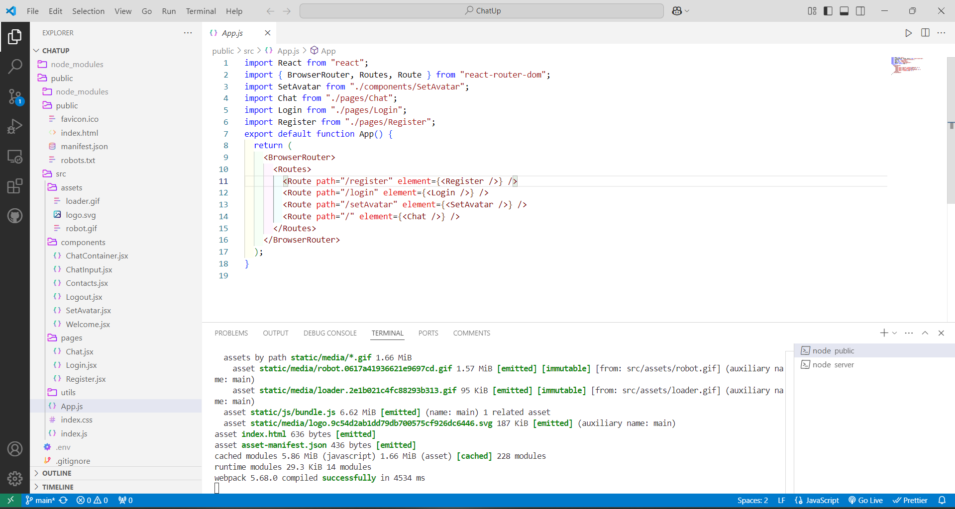

**Database Integration**

**MongoDB is used to store user data and chat history. The application connects to the MongoDB database to save messages and retrieve chat history when users log in.**

**Code Output**

Here is the first page of the project If we already have an account then login using the username and password

if we are new this application then Create one and fill the basic details then your account was created and then click too the

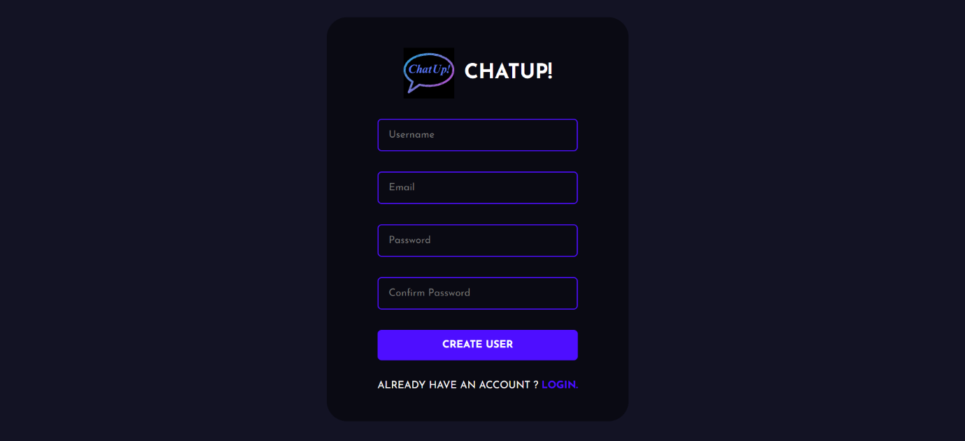

Pick the Avatar for your Suitable Profile picture

Application well shows all the user that are use this application then you randomly connect the people and start the conversations

**

Have Feature like we can express our feelings using Emoji

**Conclusion**

**The REAL-TIME CHAT APPLICATIONS project successfully demonstrates the implementation of a real-time chat system using modern web technologies. The application provides a seamless communication experience for users and showcases the capabilities of HTML, CSS, JavaScript, MongoDB, and Socket.IO. This project not only enhances our understanding of web development but also serves as a foundation for future projects in real-time communication.**

**Future Work**

**In the future, we plan to enhance the REAL-TIME CHAT APPLICATIONS application by adding features such as:**

* **User profiles with customizable settings.**
* **Group chat functionality.**
* **Enhanced security measures, including message encryption.**